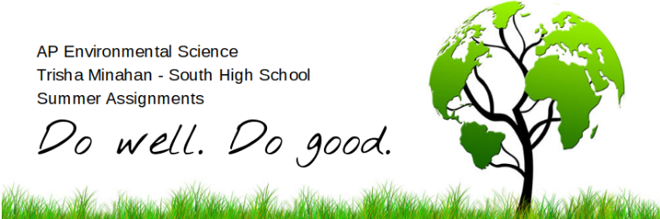

Welcome to APES! This is probably one of the most important classes you will experience in your high school career. The workload will be constant, but manageable. I expect you to put forth your best effort into two main goals: 1) pass the AP exam in May, and 2) make the world a better place by your existence.

Summer Assignment
To prepare you for these goals, your assignments consists of
- Online assignments. There are a series of readings, videos, and a math review on etusd. The required math is simple, but you must be proficient and able to perform under pressure. Go through the review I have prepared for you online and don’t skip the practice!
- Camping. Get in touch with nature and go camping. See the guidelines on etusd.
- Bring an empty two-liter plastic bottle on the first day. It must be CLEAR and STRAIGHT (no curves).

All assignments are due prior to the first day of class. Do not procrastinate! There will be a test on the first day that covers the online summer assignments. The test is open-notes. I am not collecting your summer work.

To find the details of these assignments and more about this course, log on to etusd and enroll in AP Environmental Science (the enrollment code is “apes2017”). The course is available Monday, June 26.

Textbook check-out instructions:
Living in the Environment (AP, 18th edition), G. Tyler MIller, Jr.; Scott Spoolman
Fast Track to a Five, David Hong and Karen Lionberger
You MUST have a valid SHS ID card. NO EXCEPTIONS! Students must return ALL current textbooks and be clear of all fines.

Do not hesitate to contact me with questions. My email is tminahan@etusd.org. Have a great summer!

